Consulting Fit Interview: The Stories You Need Ready
Meta description: Consulting fit interview guide: how McKinsey, BCG, Bain and tier 2 firms run the behavioral round, the six stories to prepare, and how to build each one.

A consulting fit interview is the part of a McKinsey, BCG or Bain interview where the interviewer asks about things you've done, and it sits in the same meeting as the case rather than in a separate round. At McKinsey, the Personal Experience Interview takes about 10 to 20 minutes of a 45 to 60 minute interview, and the interviewer spends all of it on one story. [VERIFY: Hacking the Case Interview says 10 to 20 minutes of 45 to 60, StrategyCase 10 to 20 of about 50, CaseCoach 15 to 20 of 45 to 50; checked October 11, 2026] BCG and Bain put 10 to 15 minutes of behavioral questions inside each case interview, and Oliver Wyman, Kearney and L.E.K. run something close. In this article, I lay out what changes from firm to firm, the six stories that cover every version of the fit interview, and how to build each one so it holds up through ten minutes of follow-up questions.

What is a consulting fit interview?
A consulting fit interview is a structured conversation about your past experiences, scored against a short list of traits the firm has decided its consultants need. The interviewer asks for one specific example ("tell me about a time you led a team"), then asks follow-up questions about what you did, what you said and what you were thinking, until they have enough detail to score you. McKinsey's careers page tells candidates to prepare two personal examples for each of four areas, and to focus on "your specific role" and "the key actions that were critical to success." [VERIFY: mckinsey.com/careers/interviewing wording, October 2026] The case interview tests whether you can think through a business problem. The fit interview tests whether the firm can put you on a team and in front of a client.

How many stories do I need for consulting interviews?
Six, each one built so you can tell it from two angles. One story can answer a leadership question or a conflict question depending on which part you lead with, and that's what lets six stories cover more than six questions. Every firm's fit questions come from the same handful of themes: leading a group, changing someone's mind, failing, working through a conflict, starting something and solving a hard problem. McKinsey asks for two examples per dimension, and most offices won't let you reuse a story with a second interviewer, so a full McKinsey process with four or five interviews needs four or five distinct stories [VERIFY: StrategyCase PEI guide, "most offices also forbid reusing a story across interviewers," checked October 11, 2026]. BCG and Bain ask one to three behavioral questions per interview, drawn from the same themes, so six covers them with room to spare. Six stories, each tagged to two themes, give you two examples for every McKinsey dimension and an answer for every BCG, Bain and tier 2 question.

How each firm runs the consulting fit interview
The table below is the format at each firm as of October 2026. Firms change the order and the minutes office by office, so treat it as the default and confirm the details with your recruiter.

Firm | What the firm calls it | Where it sits | How long | What to expect
McKinsey | Personal Experience Interview (PEI) | Opens every interview, before the case | About 10 to 20 minutes [VERIFY: Hacking the Case Interview and StrategyCase say 10 to 20, CaseCoach 15 to 20; checked October 2026] | One story on one dimension, drilled with 10 to 25 follow-up questions
BCG | Behavioral questions; the careers page calls the first meeting a "Skills Interview" | Inside each 45 minute interview, usually before a 25 to 30 minute case | 10 to 15 minutes [VERIFY: Hacking the Case Interview BCG page, June 14, 2026] | Why BCG, why consulting, then one or two "tell me about a time" prompts
Bain | Behavioral questions, scored on a rubric | Opens the interview in most offices; some offices run the case straight through | 10 to 15 minutes where it runs [VERIFY: Hacking the Case Interview and PrepLounge Bain pages, 2026] | The same scripted questions for every candidate in a role
Oliver Wyman | Fit interview | First part of each first-round interview, then a case | About 15 minutes [VERIFY: PrepLounge Oliver Wyman guide, April 2026] | CV walk-through, motivation, accomplishments, outside interests
L.E.K. | Behavioral discussion | Start or end of each case interview | 5 to 10 minutes in round one, longer with partners [VERIFY: StrategyCase L.E.K. fit page, May 2026] | Why L.E.K., why diligence work, one or two stories
Kearney | Behavioral part of each interview | Inside each 55 minute first-round interview | Not fixed [VERIFY: PrepLounge Kearney guide, August 2025] | Background, motivation, then teamwork and conflict

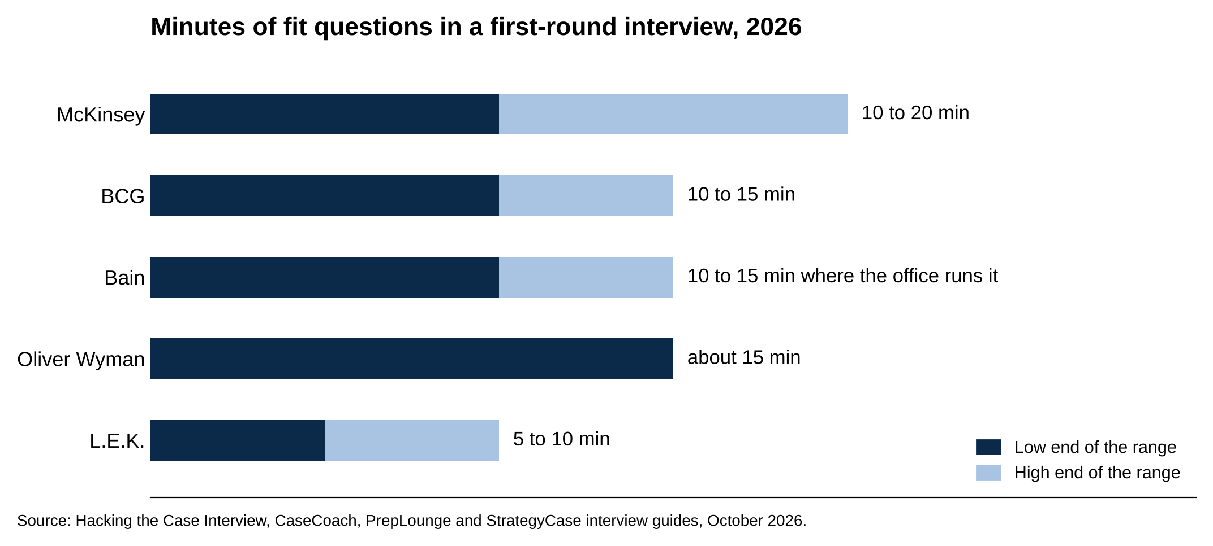
McKinsey gives fit 10 to 20 minutes per first-round interview; L.E.K. gives it 5 to 10.
Source: Hacking the Case Interview, CaseCoach, PrepLounge and StrategyCase interview guides, October 2026.

McKinsey runs one story per interview

Each McKinsey interview opens with the Personal Experience Interview, then moves to the case. The interviewer picks one of four dimensions (Leadership, Connection, Drive or Growth), asks for one story, and spends the whole PEI on it [VERIFY: mckinsey.com/careers/interviewing loads its theme labels dynamically and the static page only confirms "four areas" and "two personal examples" (checked October 11, 2026); Hacking the Case Interview, StrategyCase, CaseCoach and WSG's live PEI post all list Leadership, Connection, Drive and Growth; open the McKinsey page in a browser before publish to confirm the labels]. Problem solving is scored in the case only, so none of your PEI stories needs to be built around an analysis [VERIFY: Hacking the Case Interview PEI page, June 2026].

A first-round McKinsey candidate sits two back-to-back interviews, each with its own PEI, and a final-round candidate sits two or three more, so one McKinsey process can ask for four or five different stories. [VERIFY: Hacking the Case Interview PEI page, June 2026] We cover the dimension-by-dimension prep in our guide to the McKinsey PEI.

BCG folds behavioral questions into the case interview

BCG's interview process page calls the first meeting a "Skills Interview," and in practice the fit questions and the case happen in the same 45 minute meeting [VERIFY: Hacking the Case Interview BCG interview page, June 2026]. "Why BCG" and "why consulting" come first in almost every interview, so have both answers ready before your stories. Then expect one or two "tell me about a time" prompts: a team you led, a disagreement, a time you persuaded someone, a time you failed. With 10 to 15 minutes for two or three questions, expect two or three probes per story rather than McKinsey's 10 to 25, so put your most specific actions in the opening answer.

BCG's careers page says its interviewers look for five qualities, and the list is Integrity, Intellectual Curiosity, Creative Thinking, Collaborative Mindset and Drive. [VERIFY: careers.bcg.com US interview process page, October 2026] The story grid near the end of this article shows which of your six stories covers each one.

Bain asks every candidate the same scripted questions

Bain gives every candidate for a role the same behavioral questions and scores the answers on a set rubric, so the prompts are predictable [VERIFY: bain.com/careers/hiring-process/interviewing and bain.com/careers/interview-prep wording, checked October 11, 2026]. The Bain prompts that come up most are the most proud accomplishment, the experience you wish you could do over, a time you showed leadership, a team conflict, what you'd bring to a case team and why this office. [VERIFY: Hacking the Case Interview and PrepLounge Bain question lists, 2026]

Bain's interview prep pages also tell candidates to "come ready to talk about our operating principles." One of them is "A Bainie never lets another Bainie fail," which Bain features in its own Operating Principles series. Make sure your leadership or conflict story shows you helping a teammate who was behind without being asked.

Where the fit questions sit depends on the office. Some offices open each interview with 10 to 15 minutes of them, and others give the whole first-round slot to the case [VERIFY: Hacking the Case Interview Bain page, June 2026; PrepLounge Bain guide, March 2026, which still describes about 15 minutes of fit before the case]. Ask your recruiter which format your office runs.

Tier 2 firms run a shorter version of the same thing

Oliver Wyman's fit part covers your CV, why consulting, your accomplishments and what you do outside school. PrepLounge's guide lists initiative and intuition first among the qualities Oliver Wyman screens for, so give the initiative story below the most detail if Oliver Wyman is on your list [VERIFY: PrepLounge Oliver Wyman guide, April 2026]. L.E.K.'s questions lean toward why you want commercial due diligence work (checking a company's market and customers before a private equity firm buys it), a time you were wrong about something important, and a time you changed your mind on new evidence [VERIFY: StrategyCase L.E.K. fit interview page, May 2026]. Kearney's behavioral part covers your background, your motivation and how you've handled teamwork and conflict [VERIFY: PrepLounge Kearney guide, August 2025].

Every tier 2 fit interview asks for the same six stories as MBB, in fewer minutes, with a heavier weight on why this firm. Prepare the stories once and change the "why this firm" answer per firm. Our guide to answering why consulting covers that answer.

What interviewers are scoring in a consulting fit interview
Each firm scores the fit interview against its own list of traits (McKinsey's four dimensions, BCG's five qualities, Bain's operating principles), and the story grid near the end of this article maps your six stories to all of them. At every firm, the scoring happens in the follow-up questions, which separate what you did from what the team did.

Hacking the Case Interview sorts PEI follow-ups into four types: factual checks, decision probes ("why did you do that instead of the alternative"), interpersonal probes ("what did they say back") and reflection probes ("what would you do differently") [VERIFY: Hacking the Case Interview PEI page, June 2026]. Have an answer to each type ready for every story; the follow-up lists under each story below cover all four. The interviewer scores the specific actions you took and the words you used, so a story with a great result and a vague middle scores lower than a story with a modest result and a detailed middle.

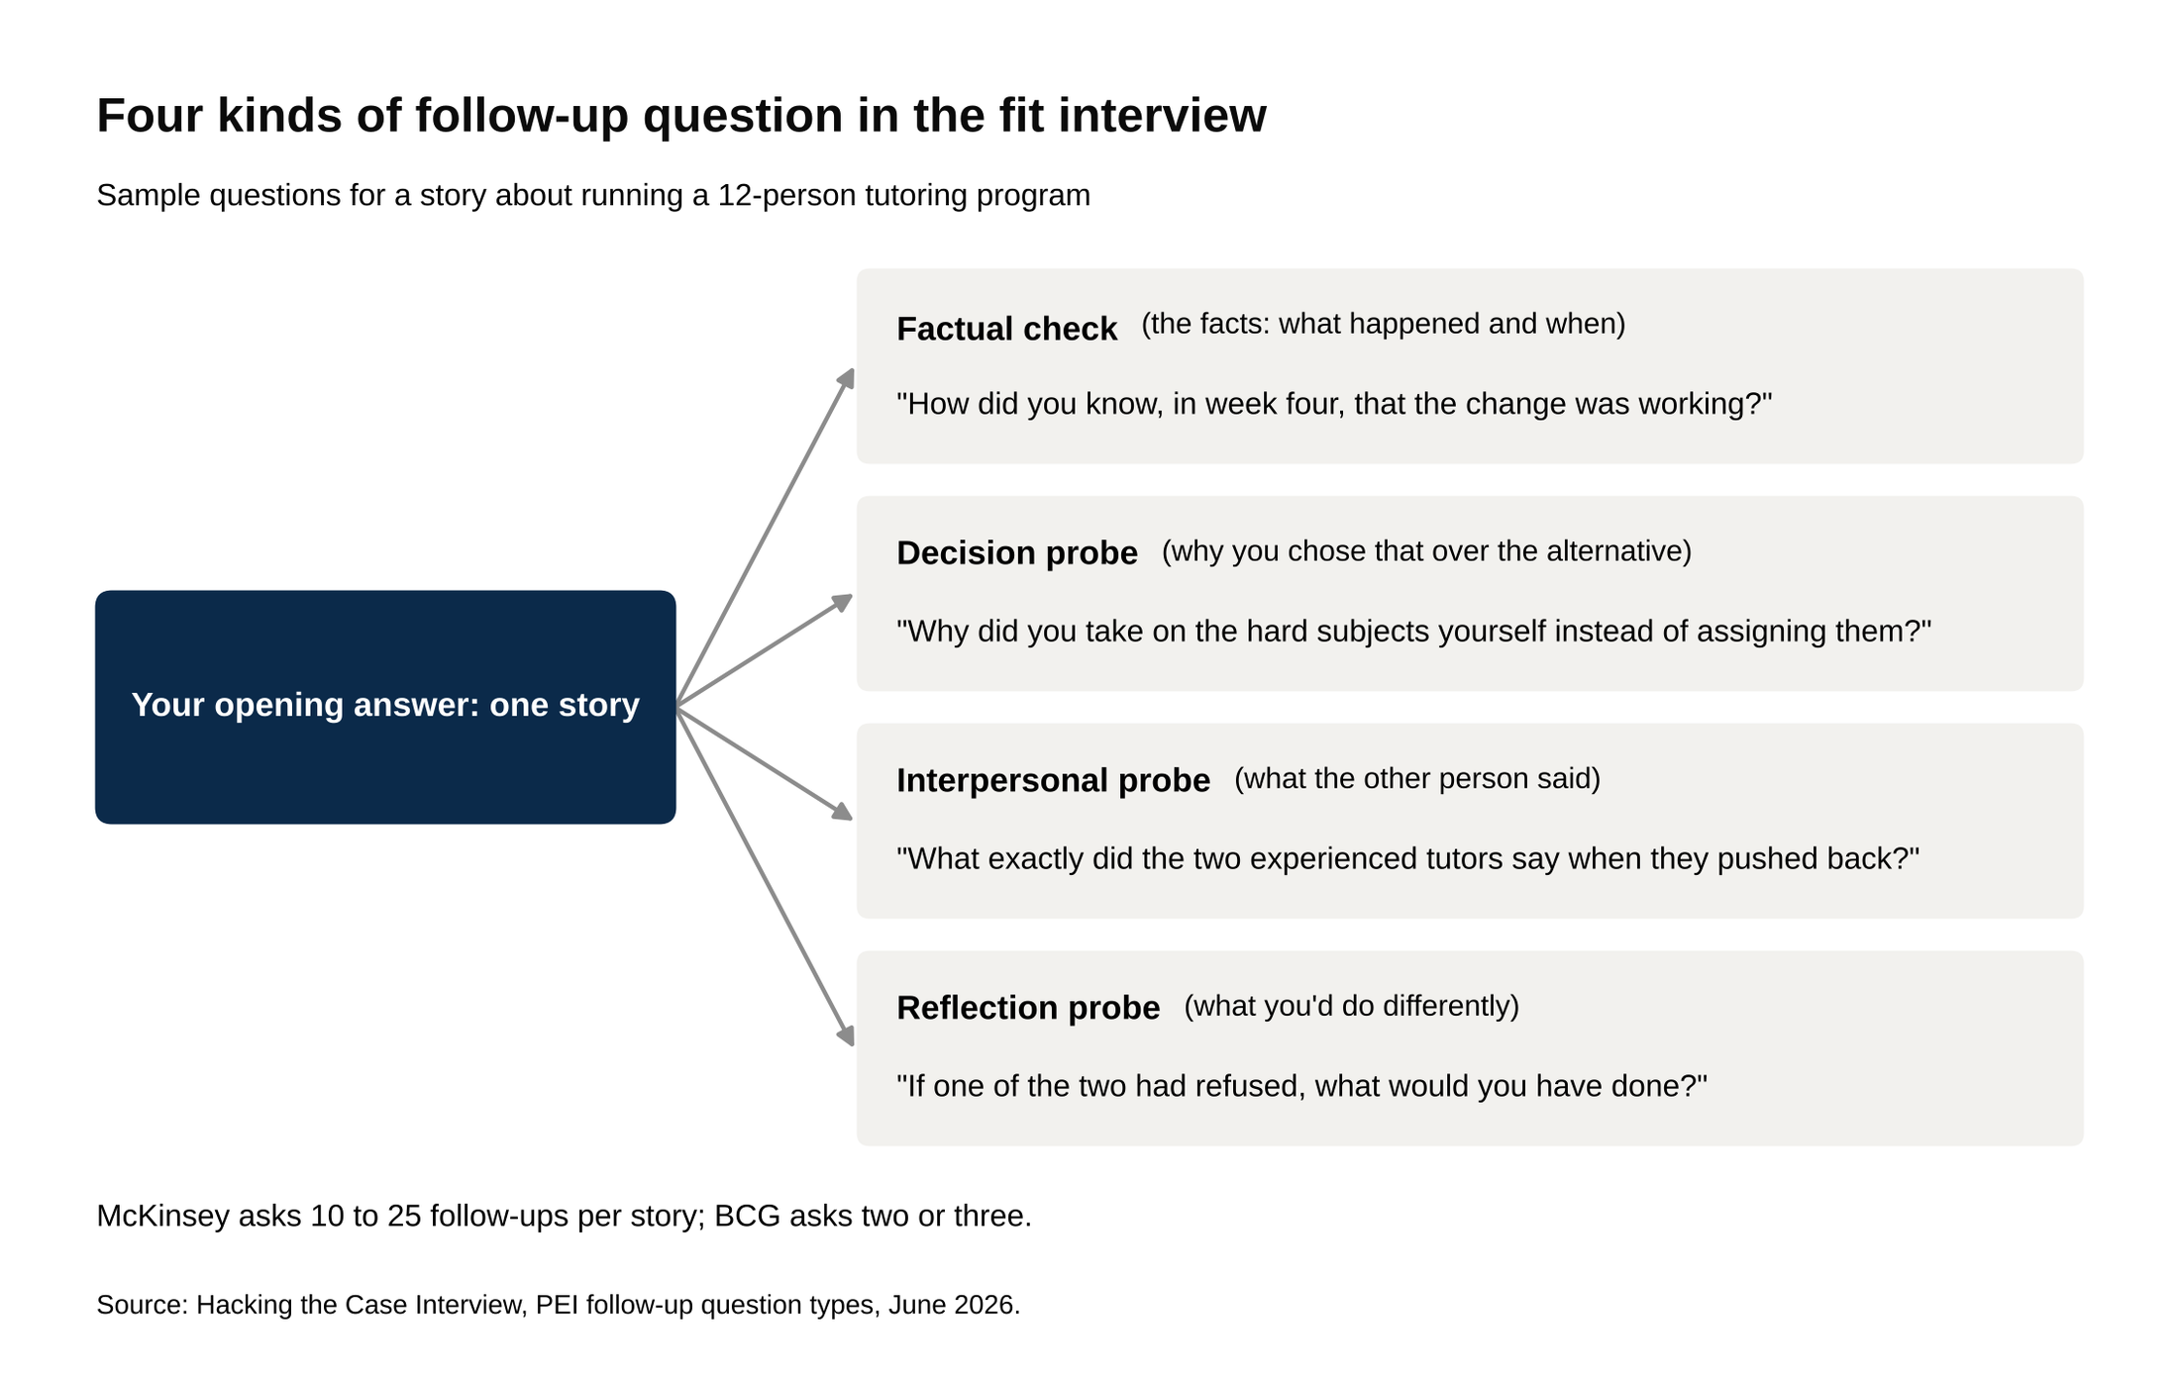
McKinsey interviewers ask 10 to 25 follow-ups per story, drawn from these four types.
Source: Hacking the Case Interview, PEI follow-up question types, June 2026.

1. The leadership story is about decisions, not a title
This story answers "tell me about a time you led a team," and the interviewer wants decisions, not a position. McKinsey scores it under Leadership. BCG scores it under Collaborative Mindset. Bain and Kearney ask for it almost word for word.

A strong leadership story has a group that had to get something done, at least two people who wanted different things, a decision you made that someone disagreed with, and the specific things you did to bring that person along. The result needs a number. The group can be small. A four-person case competition team works as well as a 40-person club, because the interviewer is scoring how you handled the people, and four people disagreeing is plenty.

Say your story is about a 12-person volunteer tutoring program you ran that was losing tutors by midterm every semester. Your setup is two sentences: the program, and the problem (half the tutors stopped showing up by week eight). Your role is one sentence: you were the coordinator and it was your call how to fix it. Then the actions, in detail. You talked to the six tutors who'd quit the previous semester and found that four of them left because they were assigned subjects they didn't know well. You proposed letting tutors pick their subjects, and two of your most experienced tutors pushed back because it would leave the hard subjects uncovered. You sat down with both of them, agreed to cover the hard subjects yourself for the first month, and asked them to train two newer tutors in those subjects. By the end of the semester, 10 of 12 tutors were still active, up from 6 of 12 the semester before.

The follow-ups on a leadership story go after the disagreement. What exactly did the two experienced tutors say when they pushed back? What did you say back? Why did you take on the hard subjects yourself instead of assigning them? How did you know, in week four, that the change was working? What were you thinking at the moment they pushed back? If one of the two had refused, what would you have done?

Have a real answer for each.

A leadership story fails when the candidate held a title but made no decision anyone disagreed with. "I was president and we grew the club" gives the interviewer nothing to score. The other common failure is "we" from start to finish, which hides your actions behind the group's.

2. The persuasion story needs the other person's objection
This story answers "tell me about a time you changed someone's mind" or "a time you had to convince someone of your idea." McKinsey scores it under Connection. BCG and Bain ask for it directly. Hacking the Case Interview lists "give an example of when you persuaded someone" among BCG's ten most common fit questions, and Leland's Bain interview guide lists "give me an example of when you had to overcome resistance to implement a solution" [VERIFY: Hacking the Case Interview BCG page, June 14, 2026; Leland Bain Interview Guide (2025) question list, reposted by Duke Career Hub April 2026].

A strong persuasion story has one specific person, who had a real stake in the outcome and usually more authority than you, who disagreed for a reason you can state in one sentence. Then it has what you did to understand that reason, the specific change or argument that moved them, and the moment you knew they'd moved.

Say your story is about your club's $9K annual budget. The faculty advisor wanted to spend most of it sending eight members to a national conference. You wanted to spend it on a stock pitch competition on campus that would reach 60 members. Her objection was specific: the conference had been the club's signature event for a decade and alumni donors expected it. You didn't argue the point in the first meeting. You asked her who the donors were and what they cared about, and she named three who gave because the club had helped them recruit. You went back a week later with a one-page plan that invited those three donors to judge the pitch competition and gave them first access to the top finishers' resumes. She agreed to split the budget, with the competition getting the larger share. Two of the three donors judged, and one hired a finalist for a summer internship.

The follow-ups on a persuasion story go straight to the objection and the conversation. What was her actual objection, in her words? What did you say in the second meeting? How did you know she'd changed her mind rather than just given in? What would you have done if she'd said no a second time? Why did her objection make sense from where she sat? Prepare that last one hardest: you should be able to state her case as fairly as your own.

StrategyCase puts the failure mode in one line: if your answer is "I built a model that proved I was right," you have failed the dimension. [VERIFY: StrategyCase McKinsey PEI guide, June 2026] A persuasion story also fails when the other person had nothing at stake, when a group vote did the persuading, or when the "disagreement" was a misunderstanding that cleared up as soon as you explained.

3. The failure story has to be a real failure
This story answers "tell me about a time you failed," "the experience you wish you could do over" (Bain) and "a time you were wrong about something important" (L.E.K.). McKinsey scores it under Growth. The interviewer wants a decision you made that went wrong because of something you did or didn't do, a cost you can name, and what you changed afterward.

A strong failure story has five parts: the call you made, why it seemed right at the time, the moment you realized it was wrong, what you did in the days right after, and what you do differently now, with evidence that the change stuck. The cost has to be real. Something the group lost, a person who was let down, a deadline that was missed. A disguised win ("I failed to get first place, we came second") doesn't count.

Say your story is about recruiting for the same club. You were in charge of the fall recruiting drive and decided to skip the activities fair because you thought the club's reputation would carry it, and you put the time into a social media campaign instead. Applications came in at about half the previous year's number. You realized it on the application deadline, when the count was 40 against 85 the year before. You told the club's president that night rather than waiting for the next meeting, which was uncomfortable, and you asked for an extra week. You spent that week at tables outside the business school building for three hours a day with two other members, and the final count landed at about 70. The next year you ran the fair and the online campaign both, and you wrote a one-page handoff for whoever ran recruiting after you so the fair never got skipped again.

The follow-ups on a failure story test whether you own it. What was the moment you knew? Who did you tell first, and how did that conversation go? What did you feel that night? Why did skipping the fair seem reasonable at the time? What would someone else on the team say you got wrong? Answer the "why it seemed reasonable" question honestly. A decision that made sense at the time is a better story than one that never did.

A failure story fails when nobody was hurt by it, when someone else gets the blame, or when nothing changed afterward. Those three are the checks to run on your own story before you use it. A story where you fixed the damage but changed none of your habits scores as recovery, not growth.

4. The team conflict story is scored on what you said
This story answers "tell me about a conflict on a team and how you handled it." McKinsey scores it under Leadership or Connection depending on your role in it. BCG scores it under Collaborative Mindset. Bain asks for it directly, and Kearney's behavioral part names conflict as a topic [VERIFY: PrepLounge Kearney guide, August 2025].

A strong conflict story has two people (you and one other, or two others with you between them) at odds over something that mattered to the work, a real stake if the conflict went unresolved, the specific conversation where you raised it, how the other person reacted, how it was resolved, and what the working relationship was like afterward. Conflict about substance scores better than conflict about effort. "He wanted to size the market top down and I wanted to go bottom up" gives the interviewer more than "he stopped replying to messages," though both work if the conversation is detailed.

Say your story is about a four-person group project in a corporate finance class. One teammate had built the valuation model and refused to change the discount rate even after the professor's feedback said it was too low. You thought the grade depended on it. You asked him to walk you through how he'd picked the rate, and it turned out he'd pulled it from a textbook example for a different industry and was embarrassed to say so in front of the group. You suggested the two of you rebuild that one input together before the next meeting and present it as a joint change. He agreed. The model went in with a rate the professor accepted, and he asked you to pair on the next assignment.

The follow-ups on a conflict story are about the conversation. What exactly did you say when you raised it? How did he react in the first ten seconds? What did you learn about him that you didn't know going in? Why did you take it to him alone instead of raising it in the group? Would he tell this story the same way?

A conflict story fails when the candidate had power over the other person and resolved it by giving an order, or resolved it by going around them to someone senior. It also fails on "we talked it out," with no record of what was said. The interviewer will ask for the words, and if you don't have them, the story stops there.

5. The initiative story shows you started something nobody asked for
This story answers "tell me about a time you took initiative" and "a time you solved a problem that wasn't assigned to you." McKinsey scores it under Drive. BCG lists Drive as one of its five qualities. Bain's page says it looks for people who are "intellectually curious, entrepreneurial, and who find challenges exciting," and PrepLounge's Oliver Wyman guide puts initiative first on its list of what the firm screens for [VERIFY: bain.com/careers/hiring-process/interviewing wording and PrepLounge Oliver Wyman guide, April 28, 2026; both checked October 11, 2026].

A strong initiative story has a gap you noticed before anyone asked you to, a goal you set that was hard enough to fail, at least two obstacles (no budget, no permission, nobody else cared yet), what you did at each one, and a result with a number. The best ones end with something that still exists.

Say your story is about a peer finance workshop series you started as a sophomore. The gap: the career center ran resume reviews but nothing on technical interview prep, and you watched three friends get cut in first rounds on accounting questions. The goal: a weekly one-hour session, open to anyone, through the fall recruiting season. The obstacles: no room, no money for materials, and the finance club's board said it would compete with their events. You booked a classroom through a professor who agreed to sponsor it, wrote the first four sessions yourself from free materials, and offered the finance club co-branding so their members got priority seating. The first session drew about 15 people. By week six it was about 40, and the club's board asked you to run it under their name the next year. Three years on, it's a standing club program.

The follow-ups on an initiative story go after your motivation and the hard moments. Why did you care enough to do this? What was the hardest week? Who told you no, and what did you do next? What did it cost you in time, grades or other commitments? Is it still running without you? Have specific answers for the "who told you no" question; a Drive story without resistance reads as a hobby.

An initiative story fails when the project was assigned, when the obstacles never threatened the goal, or when the result is "people said it was useful." A number, even a small one, beats praise. Fifteen people at the first session is a result. "Great feedback" is a sentence the interviewer can't score.

6. The analytical story is for BCG, Bain and tier 2
This story answers "tell me about your most proud accomplishment," "walk me through a project you worked on" and, at L.E.K., "walk me through how you'd evaluate a company you'd never seen before." BCG scores it under Intellectual Curiosity and Creative Thinking. Bain's careers page says it looks for "curious problem-lovers." PrepLounge's Oliver Wyman guide lists data and analytical skills among the qualities the firm screens for. At McKinsey this story only comes up as a Drive story, when the hard problem involved pushing through setbacks, because the PEI leaves problem solving to the case [VERIFY: StrategyCase on problem solving not being a PEI dimension, June 2026].

A strong analytical story has a question nobody had the answer to, how you broke it into parts, where you got the data and what it took to get it, the one judgment call you had to make, the answer, and what someone did with it. Spend the telling on how you broke the question down; the tool you used matters much less.

Say your story is about figuring out why attendance at the club's events had dropped by about a third over two semesters. You split the question into who stopped coming and why. For the who, you pulled the sign-in sheets for 20 events and found the drop was almost entirely sophomores, while junior and senior attendance was flat. For the why, you sent a short survey to the sophomore members and got about 30 replies; the top reason was that events clashed with a required sophomore course that had moved its time slot. The judgment call was whether to trust 30 replies, and you decided they were enough because the time clash was checkable and the course's new slot matched the first semester of the drop. You proposed moving half the events to a different evening. Sophomore attendance recovered to within about 10 percent of the old level in a semester.

The follow-ups on an analytical story test whether the thinking was yours. How did you decide what to look at first? What did the data show that you didn't expect? What would you have done with another week? What did the club do with your answer? Where could you have been wrong? For that last one, name the part of your answer you're least sure of, plainly and on the first ask.

An analytical story fails when it's a class assignment with a known answer, when the spreadsheet is the hero of the story, or when nobody made a decision because of it.

How to build a story so it survives ten minutes of follow-ups
Every one of the six stories uses the same five-part structure, and the structure is what keeps you steady when the follow-ups come. The parts are a two-sentence setup, a one-sentence statement of your role, the actions in detail, a result with a number, and one thing you'd do differently. Call it STAR (situation, task, action, result), SPAR or anything else; the shape is the same. Hacking the Case Interview's timing for the PEI version is about 10 to 15 seconds of summary, 30 to 45 seconds of problem, two to three minutes of actions and 30 to 45 seconds of result [VERIFY: Hacking the Case Interview PEI page, June 2026].

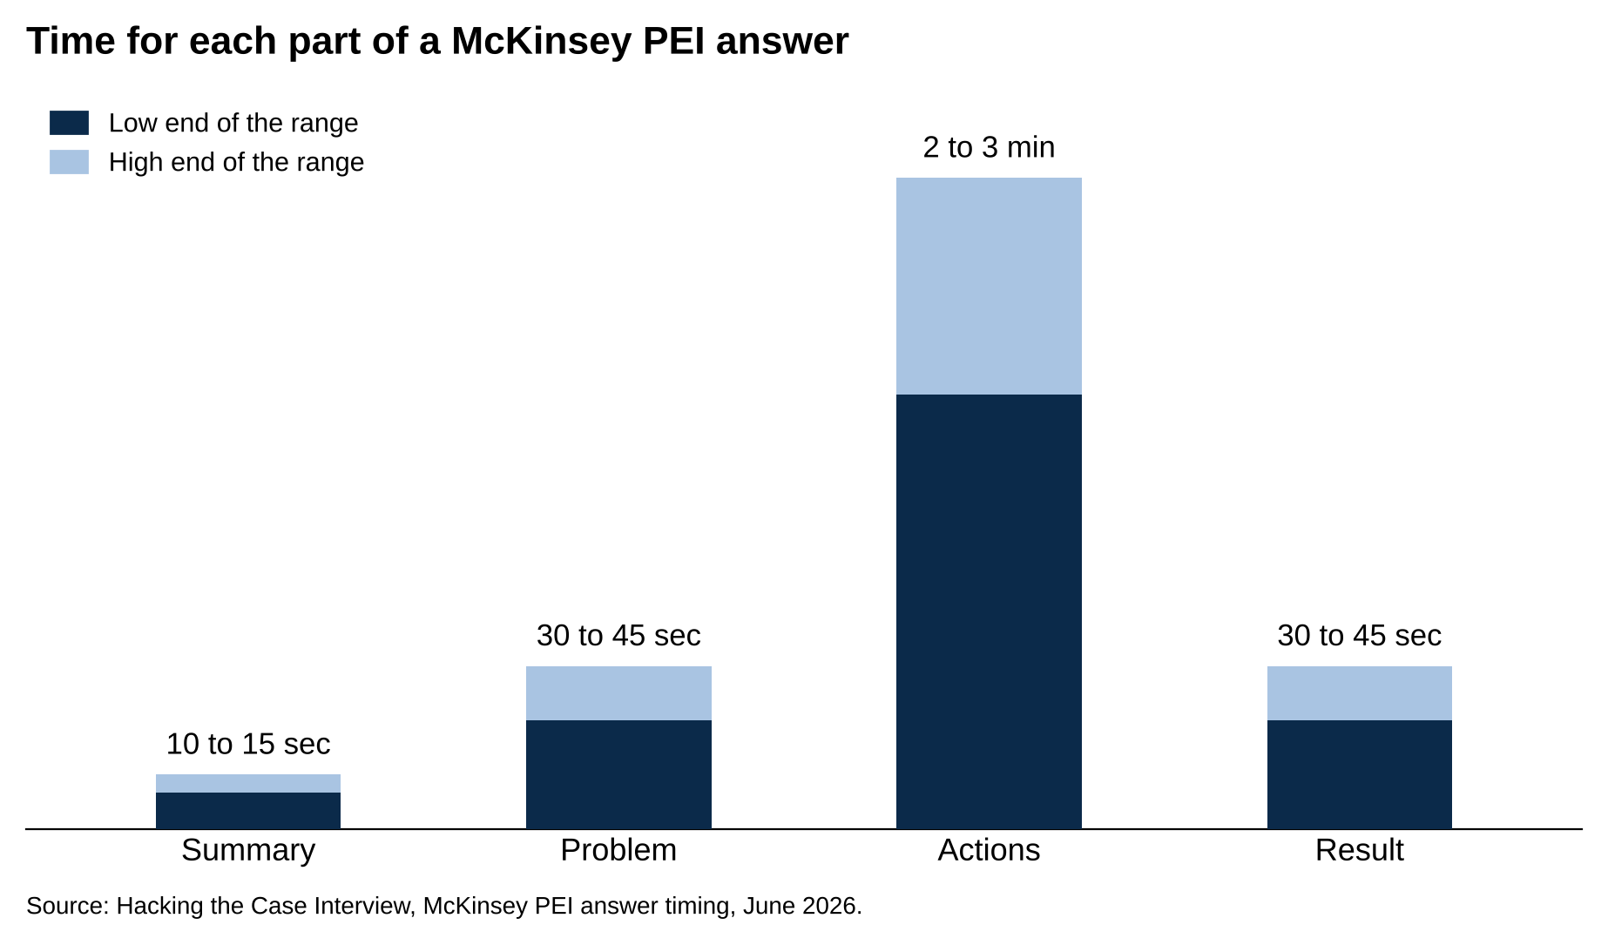
Actions get two to three minutes; summary, problem and result get 10 to 45 seconds each.
Source: Hacking the Case Interview, McKinsey PEI answer timing, June 2026.

Spend about 70 percent of the telling on the actions you took, because the actions are the only part of the story the interviewer can score. [VERIFY: Hacking the Case Interview's SPAR timing (two to three minutes of actions in a three to four minute answer) works out to about 60 to 65 percent on actions; StrategyCase recommends about 80 percent; 70 sits between the two. Both pages June 2026, checked October 11, 2026] Keep the setup to two sentences. If the interviewer needs more context, they'll ask.

Say "I," not "we," for every action that was yours. A sentence like "we decided to split the budget" tells them nothing about your role in the decision, and the next follow-up will be "what was your part in that," which costs you a question. "We" is fine for the group's results and for things the team did without you. StrategyCase's warning is "hiding behind 'we' most of the time," and the fix is to name your actions one by one [VERIFY: StrategyCase McKinsey PEI guide, June 2026].

Put a number in every result. Tutors retained, applications received, attendance recovered, dollars reallocated. Round numbers are fine and read as honest; "about 40" is better than "43." A result without a number reads as a guess about whether the story worked.

Answer follow-ups in one to three sentences and stop.

The interviewer will ask the next one. Restarting the whole story at each follow-up burns the time the interviewer needs for the next question. If a follow-up asks about something you don't remember, say so and give your best reconstruction; a made-up quote tends to fall apart two questions later.

Then build the one-page grid. Down the left side, the six stories. Across the top, the five parts. Fill each cell in note form, not sentences: "advisor objected: decade-old event, donors expect it." The grid is what you review the night before each interview, and it's where you'll see which stories are thin. Every actions cell should hold at least four or five specific things you did and at least one thing you said. If a cell has one line in it, that story won't survive the drill-down.

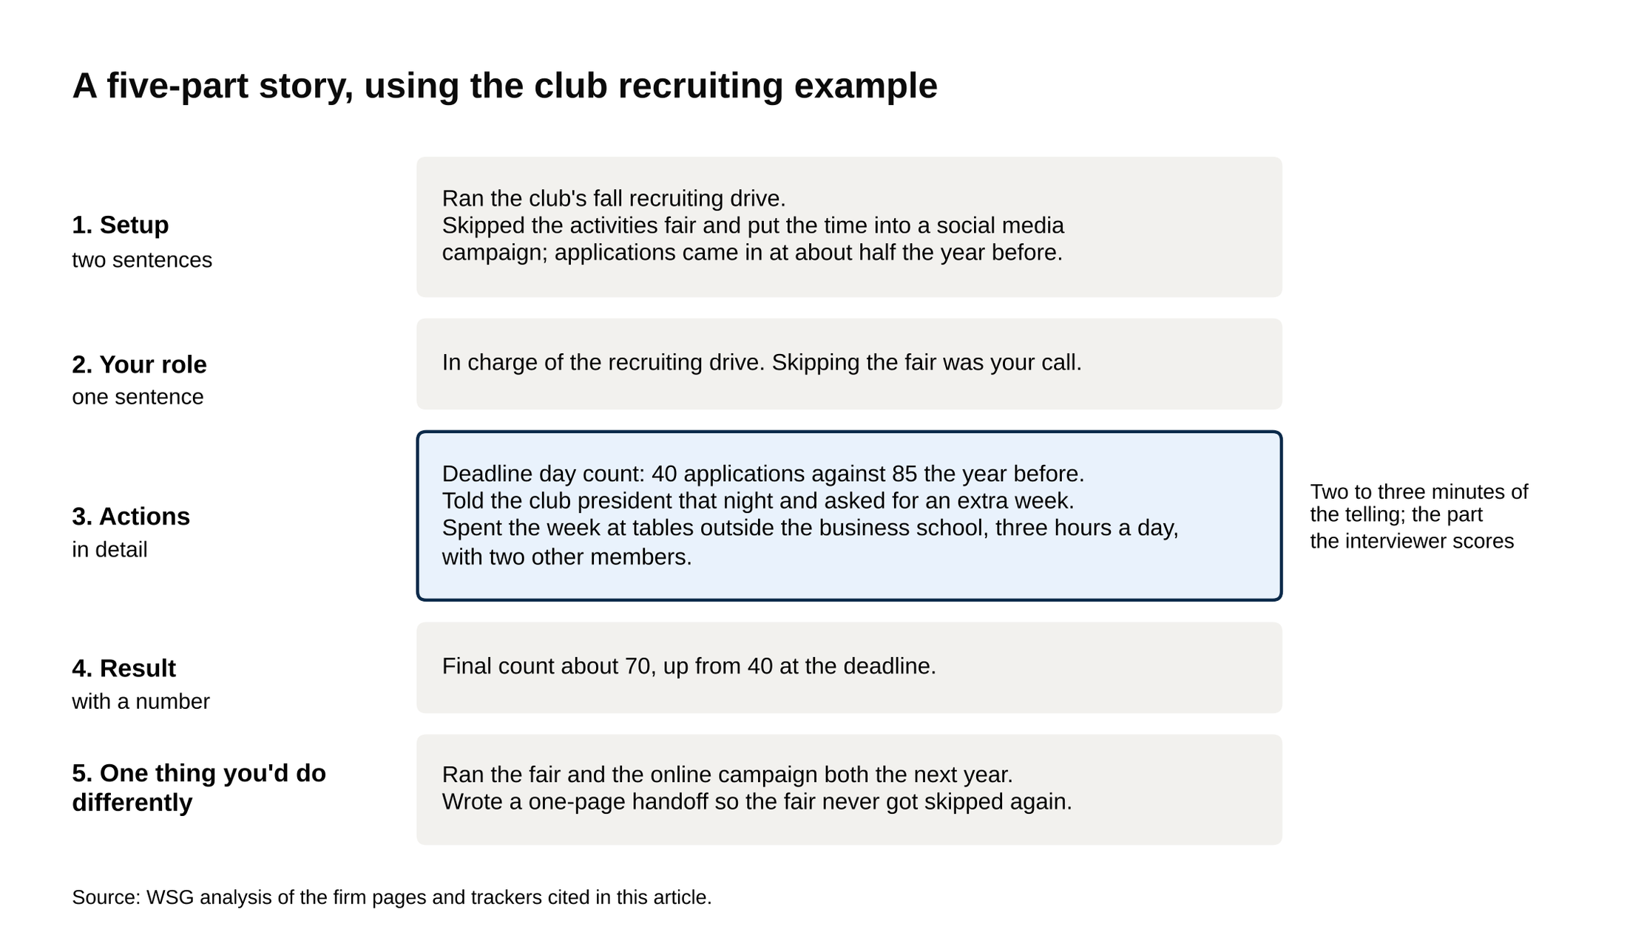
The shaded actions block is the part the interviewer scores and gets two to three minutes of the telling.
Source: WSG analysis of the firm pages and trackers cited in this article.

The last step is practice against a partner whose only job is to ask follow-ups. Give them the list of probes from each story section above and tell them to ask "what did you say" and "why did you do that" until you run out of answers. Two sessions per story is usually enough to find the holes. If a story runs out of answers after the third follow-up, swap it for a different event rather than inventing details; a true story gets better under questioning, and a padded one gets worse. Our guide to preparing for a consulting interview covers how to fit this in beside case practice.

The story grid: which story covers which firm
The table below maps the six stories to each firm's language. Print it, tag each of your six stories with its two dimensions, and you'll walk into any firm's fit interview knowing which story the question is really asking for.

Story | McKinsey PEI dimension | BCG quality | Bain prompt | Tier 2 (OW, L.E.K., Kearney)
1. Leadership | Leadership (second tag: Drive, if you pushed through resistance) | Collaborative Mindset | A time you showed leadership; what you'd bring to a case team | Kearney: leadership and teamwork
2. Persuasion | Connection (second tag: Leadership) | Collaborative Mindset, Integrity | Overcome resistance to implement a solution | L.E.K.: changed your mind on new evidence (told from the other side)
3. Failure | Growth (second tag: Drive, for the recovery) | Drive (how you recovered) | The experience you wish you could do over | L.E.K.: a time you were wrong about something important
4. Team conflict | Leadership or Connection | Collaborative Mindset | A team conflict and how you resolved it | Kearney: conflict resolution
5. Initiative | Drive (second tag: Growth, if you had to change course) | Drive | Initiative on a problem that wasn't assigned to you | Oliver Wyman: initiative
6. Analytical problem | Drive, if it involved setbacks (otherwise not scored in the PEI) | Intellectual Curiosity, Creative Thinking | Most proud accomplishment; "curious problem-lovers" | Oliver Wyman: data and analytical skills; L.E.K.: evaluating a company

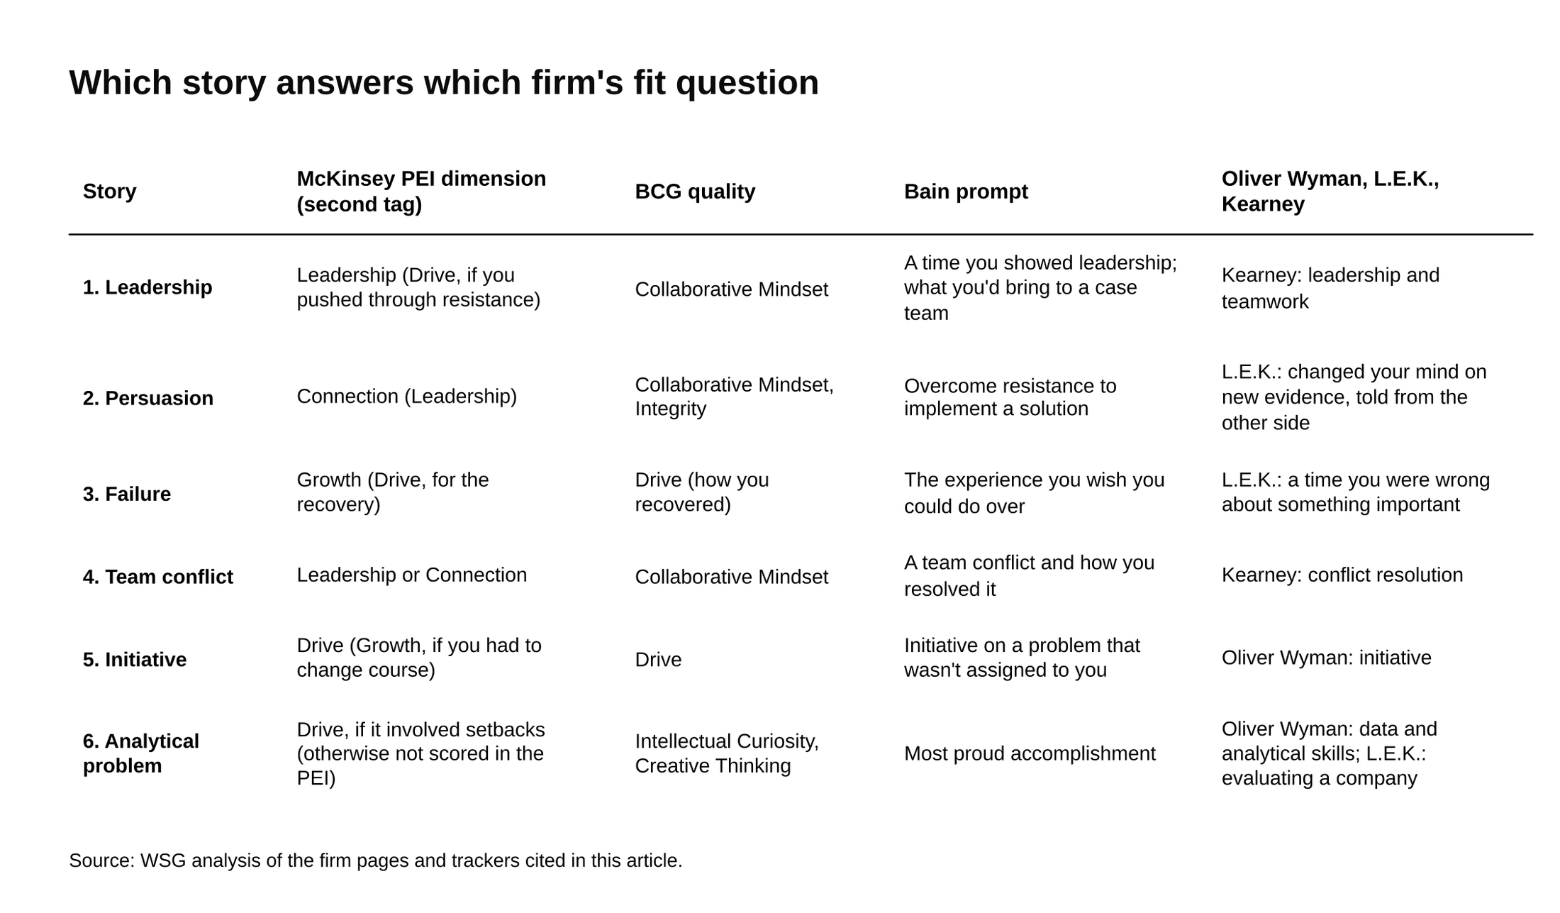
Each story carries a first and second McKinsey tag, so six stories give two examples per dimension.
Source: WSG analysis of the firm pages and trackers cited in this article.

[VERIFY: dimension and quality names against the firm pages at publish; McKinsey labels October 2026, BCG five qualities October 2026]

Two things to notice in the grid. First, the conflict story can serve McKinsey's Leadership or Connection dimension depending on which part you lead with, so it's the one to prepare most carefully if McKinsey is on your list. Second, the analytical story earns its place through BCG and Bain, and through the tier 2 firms whose work is heavier on diligence and data. With each story tagged to two dimensions, six stories give you at least two examples for every McKinsey dimension, which is the count McKinsey's own page asks for. Leadership gets stories one and four, Connection gets two and four, Growth gets three and five, and Drive gets five plus the resistance in one, the recovery in three or the setbacks in six.

A candidate with a McKinsey first round in three weeks should fill the grid for stories one through five first and write the second tag next to each one. A candidate with BCG or Bain first should make sure story six is as detailed as the others, because "most proud accomplishment" is on both firms' regular lists.

Say this, don't say that
Say this: "I asked her who the donors were and what they cared about, and she named three who gave because the club had helped them recruit." Don't say this: "I listened to her concerns and found common ground." The first is an action the interviewer can score. The second is a description of an action with the action removed.

Say this: "I told the president that night. He was quiet for a few seconds and then asked what I needed, and I asked for an extra week." Don't say this: "I took full ownership and communicated transparently with leadership." The interviewer wants the conversation, not a label for it.

Say this: "Ten of twelve tutors were still active at the end of the semester, up from six the semester before." Don't say this: "Retention improved significantly and the program was much healthier." A number is a result. "Significantly" is a guess.

Say this: "I decided to cover the hard subjects myself for the first month, because the two experienced tutors were right that nobody else could yet." Don't say this: "We decided as a team to redistribute the coverage." If you made the decision, say so. If the team made it, say what your part was.

Say this: "Looking back, I should have run the fair and the online campaign both, and that's what I did the next year." Don't say this: "My biggest failure is that I care too much about getting things right." A failure with no cost and no change isn't a failure story.

